**NAME - PRANAV SANDEEP RAIKAR ROLL NO - 45**

**DIV - D10A BATCH - B**

**Commands for File System Management and User Management**

**LAB 1**

**A.Study of Unix file system (tree structure), file and directory permissions, single and multiuser environment.**

The Unix file system is organized in a hierarchical tree structure, with the root directory (denoted by '/') as the top-level directory, and other directories and files branching off from it. Directories can contain other directories and files, allowing for a hierarchical organization of data.

In Unix, file and directory permissions determine who can access, read, write, and execute files and directories. File permissions are specified using a set of nine bits that correspond to the permissions for the owner of the file, the group associated with the file, and all other users. Each set of three bits represents the read, write, and execute permissions for the corresponding user or group. For example, the permission string "rwxr-xr-x" indicates that the owner of the file has read, write, and execute permissions, the group has read and execute permissions, and all other users have read and execute permissions.

In a single-user environment, only one user has access to the computer and its file system. In this scenario, file and directory permissions are not as important, since there is only one user who needs access to the files.

In a multi-user environment, multiple users have access to the computer and its file system. In this scenario, file and directory permissions play a crucial role in determining who can access and modify files. This helps to ensure the security and privacy of sensitive files, and prevents unauthorized access and modification of files by other users.

**Execution of File System Management Commands\**



The pwd command writes to standard output the full path name of your current directory (from the root directory).

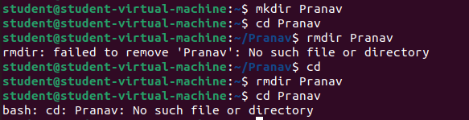

The mkdir command in Linux/Unix allows users to create or make new directories.

cd command changes from one directory to another.

rmdir removes directory

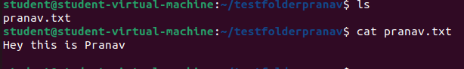

cat command opens the content present in the text file

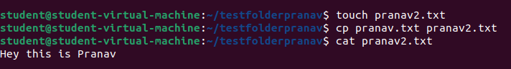

touch command creates a new file

cp command copies the content from first file mentioned to second file mentioned

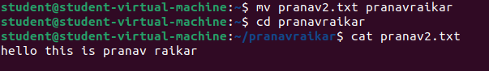

mv command is used to move one file to another file



chmod sets permissions to access the files

0 in the above command denies all permissions on the file



The wc command in UNIX is **a command line utility for printing newline, word and byte counts for files**. It can return the number of lines in a file, the number of characters in a file and the number of words in a file.



We can find the number of lines that matches the given string/pattern

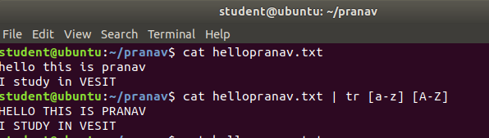

The tr command is a UNIX command-line utility for translating or deleting characters. It supports a range of transformations including uppercase to lowercase, squeezing repeating characters, deleting specific characters, and basic find and replace. It can be used with UNIX pipes to support more complex translation. tr stands for translate